fetch cache options

|  |  |  |
| --- | --- | --- |
| Api | Cache option | Reasoning |
| /api/login | No-store | User data could change |
| /api/conference-dates | No-store | New conference dates could be added in the future |

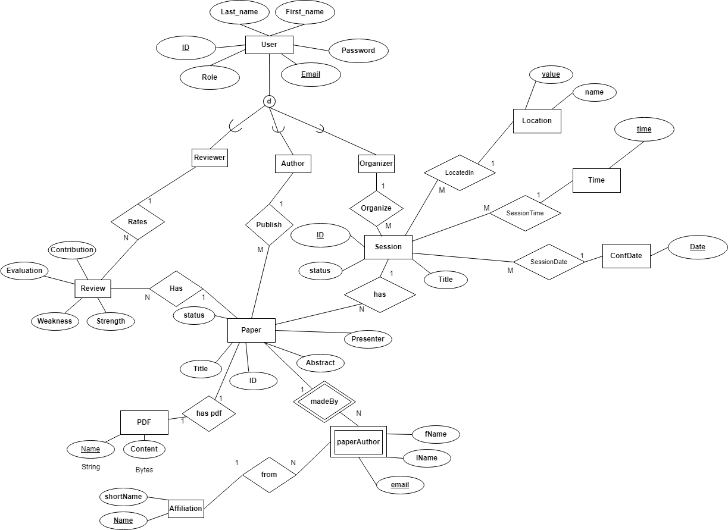

Technical Lessons Learned:

1. The first ERD does not need to be absolutely correct the first time. The advantage of prisma migrations is that we can always update our schema whenever we find we missed something or need to modify. At the same time, the rest of the team could work on the project using prisma client with little modifications needed later. The key here is saving time working on the project while the schema gets modified.

Improvement actions: